Warm Hearts, Warm Paths Initiative

Date: 28th Nov 2025, 9:00 am
Venue: Shree Janhit Secondary School, Khanikhola 7, Kavre
Donation: Tracksuits
Beneficiaries: 162
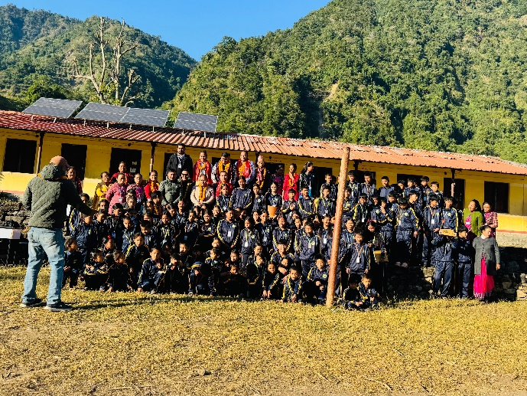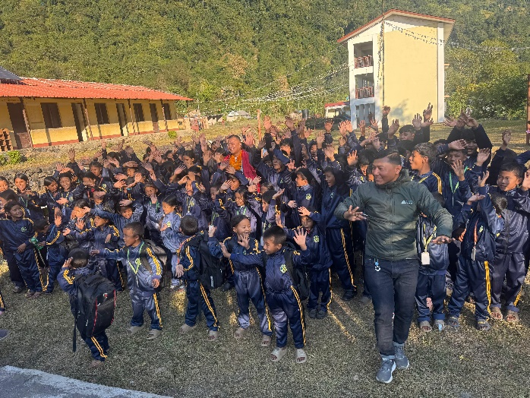
The Warm Hearts, Warm Paths Initiative was carried out at Shree Janhit Secondary School in Khanikhola-7, Kavre, a region that remains economically challenged and geographically difficult to access. Understanding the need for warm clothing during the harsh winter months, the club supported 162 students by providing them with high-quality tracksuits. Each tracksuit proudly carried the Rotary logo, symbolizing care, support, and our commitment to community service.
The total cost of the tracksuits amounted to NPR 125,550, with an additional NPR 15,000 spent on transportation to deliver the items to this remote area. Representing the club, Rtn. Khadga Zimba (Service Project Chair) and Rtn. Ratna Bdr. Khatri (Sergeant-at-Arms) undertook the trip to personally hand over the donations to the students.
Although the journey to Khanikhola was long and challenging, the warm smiles and excitement of the children made every moment and every rupee spent truly meaningful. The project not only provided comfort and protection to the students but also reinforced our commitment to uplifting underserved communities and ensuring that no child is held back due to the lack of basic necessities.

