Bhaktapur Fellowship – Heritage Walk for End Polio Mission
📅 25th Oct 2025 | 📍 Bhaktapur Durbar Sqaure
Members: 24

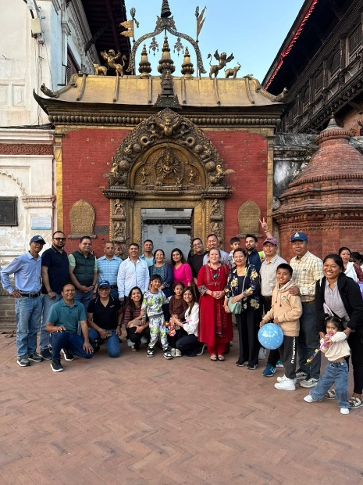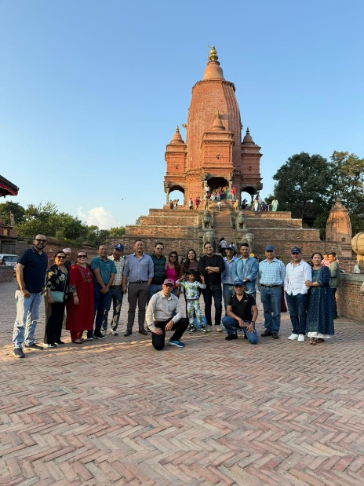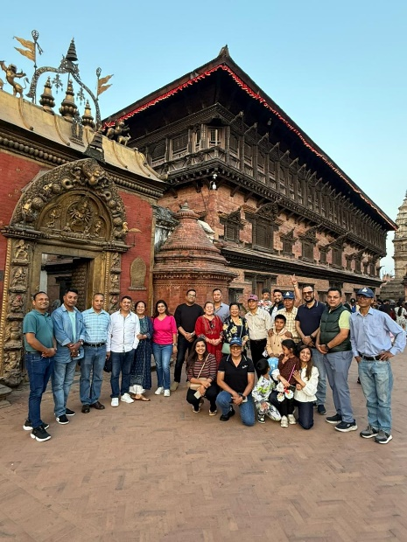

Rotary Club of Baneshwor successfully organized a memorable Bhaktapur Heritage Walk Fellowship on 25th October 2025 in support of Rotary’s End Polio mission. The event, open to members and their families, saw an enthusiastic participation of 24 members and 5 children. The fellowship began with a meet-up at the historic 55-Window Palace followed by delightful local snacks and tea at Vajra Boutique Hotel. A knowledgeable local guide then led the group through the ancient streets of Bhaktapur, sharing rich insights into the city’s cultural heritage and history. After an engaging two-hour walk, members returned to the hotel for dinner and fellowship, where everyone shared their reflections from the day. A heartfelt thanks to Rtn. Ratna and Rtn. Khadga for flawlessly coordinating the event. TRF Chair PP Arun Bansal also utilized the opportunity to encourage contributions towards The Rotary Foundation, reinforcing Rotary’s mission of service and global impact. It was truly a wonderful day of learning, bonding, and celebrating our heritage for a noble cause.

