Free Health Checkup & Blood Donation Camp with Alfa Care
📅 18th Oct 2025 | 📍 Alfa Beta Complex, Baneshwor

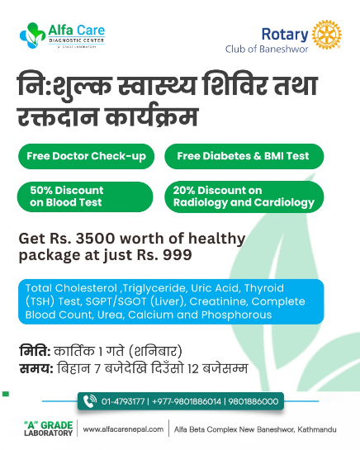
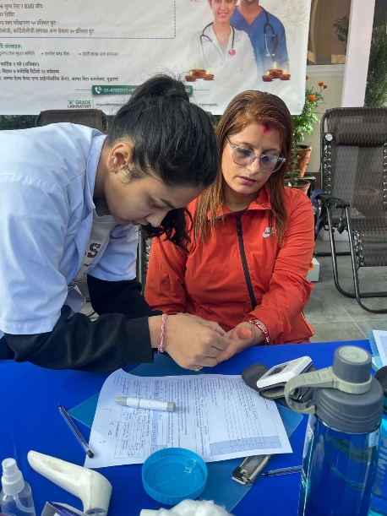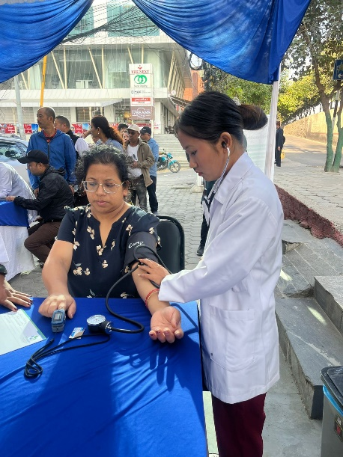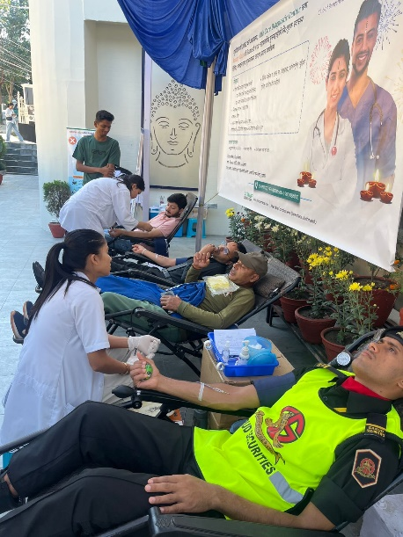
Rotary Club of Baneshwor, in collaboration with Alfa Care, successfully organized a Free Health Check-up and Blood Donation Camp on 18th October 2025 at Alfa Beta Complex, Baneshwor. The initiative offered free doctor consultations, free diabetes and BMI screenings, along with 50% discount on blood tests and 20% discount on radiology and cardiology services. In addition, a special comprehensive health package valued at Rs. 3,500 was made available to attendees at a subsidized rate of just Rs. 999. The camp received an overwhelming response, attracting over 200 individuals, with 25+ donors contributing blood for a noble cause. The program was a meaningful effort towards promoting community health and creating awareness on preventive healthcare, reinforcing Rotary’s commitment to service and well-being of society.

